R. Reports Menu: 7. Print Late Notices

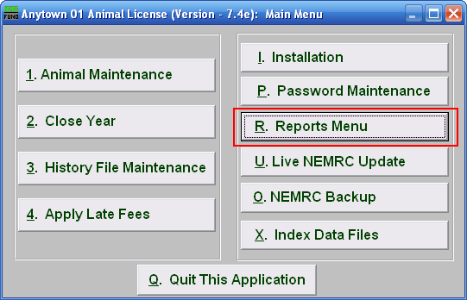
Click on “R. Reports Menu” from the Main Menu and the following window will appear:

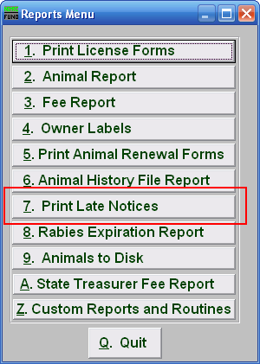
Click on “7. Print Late Notices” from the Reports Menu and the following window will appear:

Print Late Notices

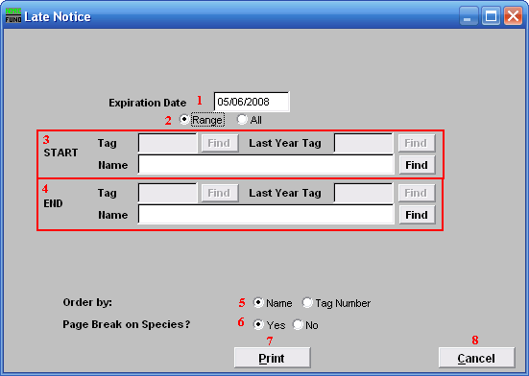
- Expiration Date: Enter the Expiration date that you want to print on the notices.

- Range OR All: Choose whether this report will be on a Range of, or All animals.

- Start: This is only available if you chose “Range.” Enter the tag number, or last year tag number, of the animal you wish to start with, or click “Find” and select from the Lookup table.

- End: This is only available if you chose “Range.” Enter the tag number, or last year tag number, of the animal you wish to end with or click “Find” and select from the Lookup table.

- Order by: Select whether this report will print in order of Owner Name, Tag Number, or Species/Breed.

- Page Break on Species?: Select if this report will start a new page for each species.

- Print: Click this button to print. Refer to GENERAL PRINTING for more information.

- Cancel: Click “Cancel” to cancel and return to the previous screen.

